Homework 3 – Motion Estimation & Compensation
314552046莊明憲
SPEC
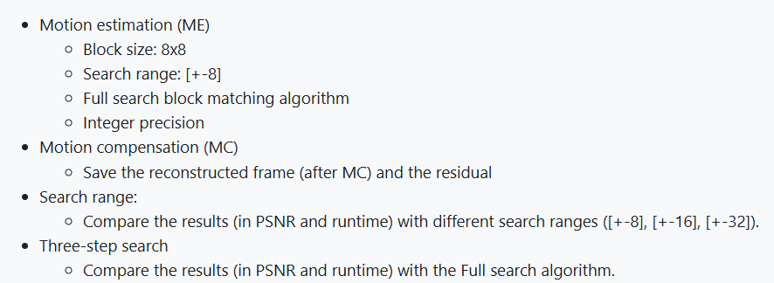
Results
Search Range : 8
Full Search  Reconstructed | Full Search Residual | Three Step Search Reconstructed | Three Step Search Residual
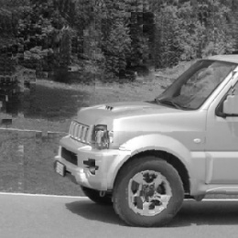 | 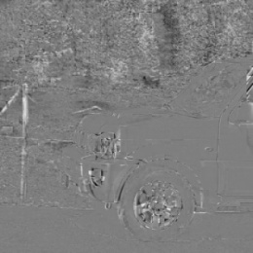 | 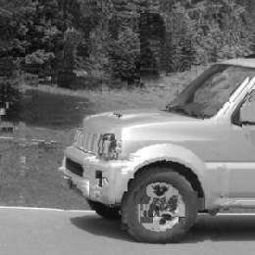 | 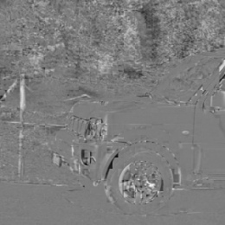

Search Range : 16
Full Search  Reconstructed | Full Search Residual | Three Step Search Reconstructed | Three Step Search Residual
 | 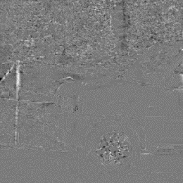 | 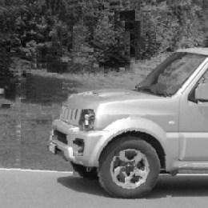 | 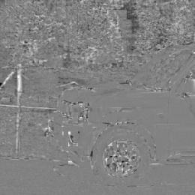

Search Range : 32
Full Search  Reconstructed | Full Search Residual | Three Step Search Reconstructed | Three Step Search Residual
 | 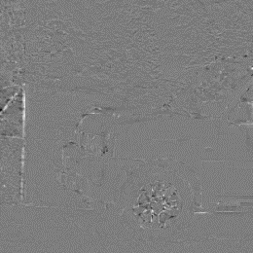 | 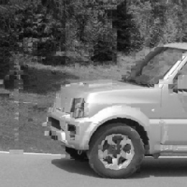 | 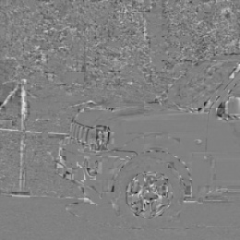

Comparison
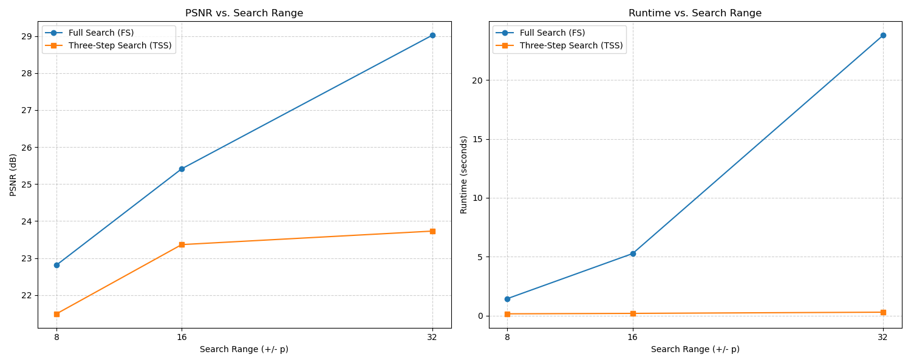
 | Search Range : 8 |  | Search Range : 16 |  | Search Range : 32
 | PSNR(dB) | Runtime(s) | PSNR(dB) | Runtime(s) | PSNR(dB) | Runtime(s)
Full  Search | 22.811 | 1.446 | 25.412 | 5.270 | 29.019 | 23.793
Three Step Search | 21.494 | 0.156 | 23.364 | 0.192 | 23.729 | 0.294
TSS vs. FS | -1.317 dB | 9.27x faster | -2.048 dB | 27.44x faster | - 5.291 dB | 80.93x faster
- Full Search (FS) Performance
The PSNR for Full Search significantly improves as the search range expands, rising from 22.811 dB (p=8) to 29.019 dB (p=32). This strong correlation suggests the video sequence contains high motion, as better matches are consistently found at greater distances. As expected, the runtime grows dramatically from 1.446 s to 23.793 s. This behavior is due to the algorithm's O(p^2) complexity, which requires checking every possible candidate block in the expanding search area.
- Three-Step Search (TSS) Performance
In contrast, the PSNR for TSS stagnates quickly after p=16, peaking at only 23.729 dB. This demonstrates the algorithm's primary limitation, as it gets "lost" and settles for a local minimum when the true motion vector lies far from the center. The main advantage of TSS is its speed, with runtime remaining nearly constant (0.156 s to 0.294 s). This is because TSS performs a fixed, low number of comparisons regardless of the search range.
- Conclusion and Trade-off
This high-motion video clearly illustrates the algorithm trade-off. TSS is significantly faster (up to 80.93x at p=32), but this speed comes at a severe quality cost, losing 5.291 dB of PSNR. For this sequence, TSS is an unsuitable choice as it fails to track the large motion. While computationally expensive, Full Search is the only method that successfully finds the correct motion vectors, proving its necessity for high-motion scenarios.

